DIS-POINTS-Etley-Missouri- Boone Co.

Material: an attractive grey Oolithic flint material 3 1/4" long Etley point

From: Boone Co.,

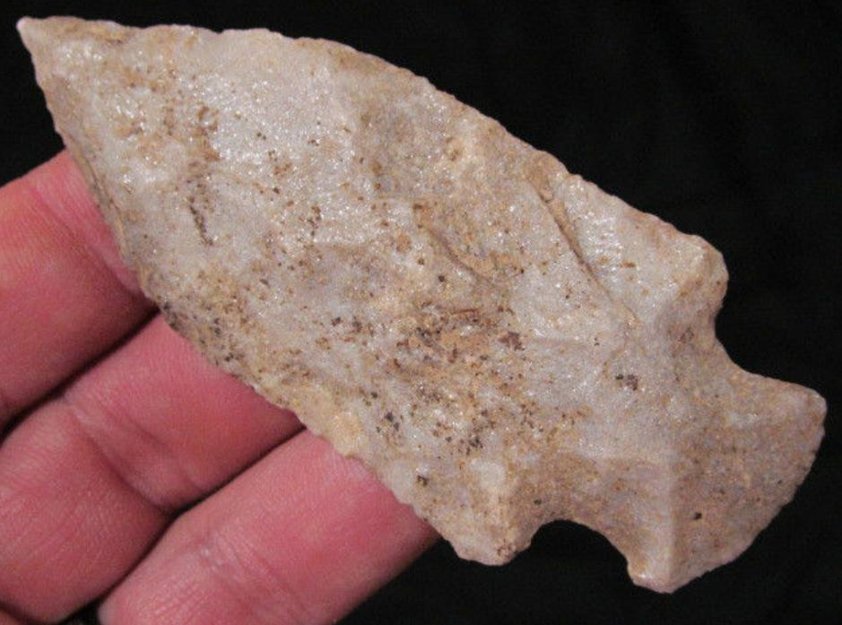 SHAPE \* MERGEFORMAT 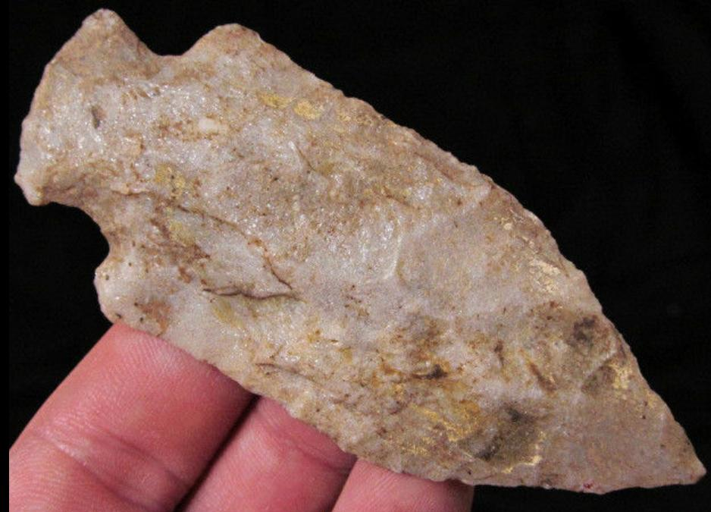

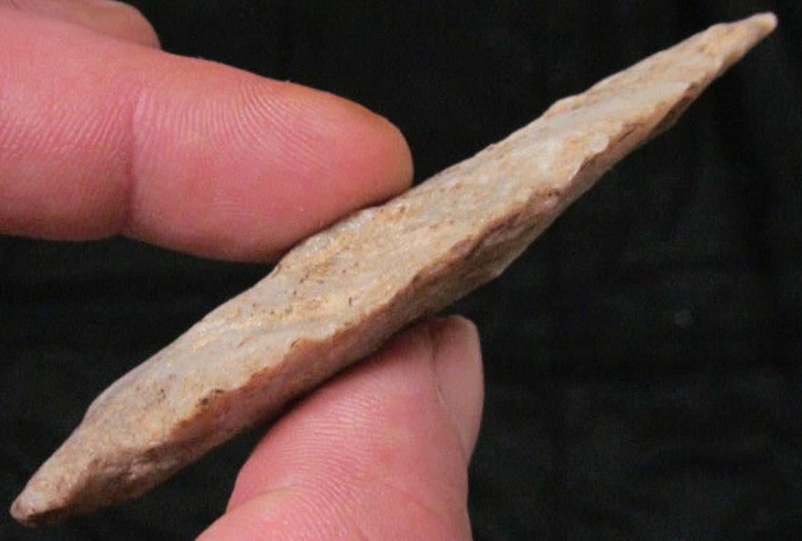

2 7/16" long Heavy Duty point

From: Licking Co., Ohio

Material: an attractive grey and tan multicolored flint material

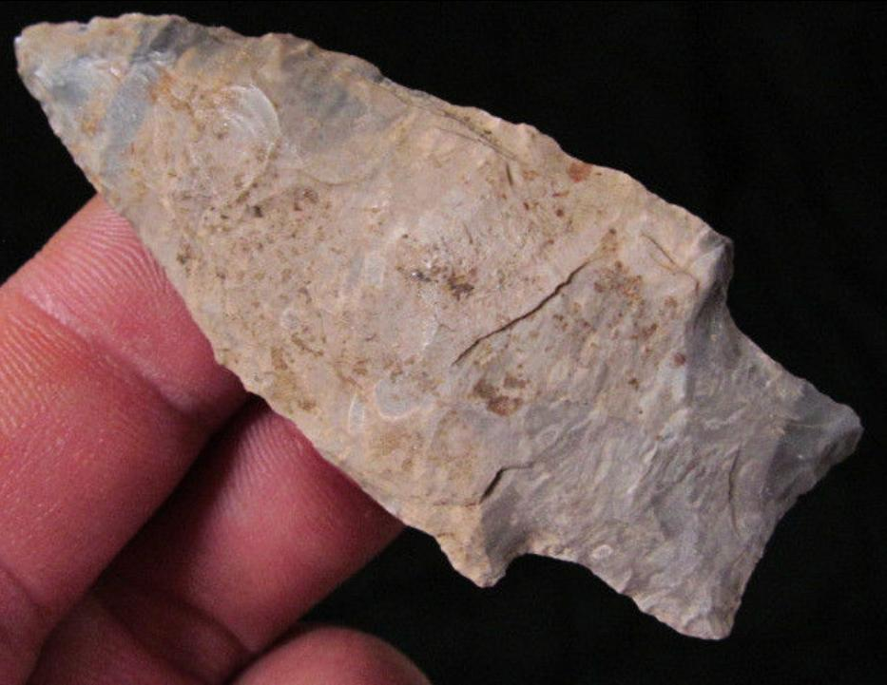 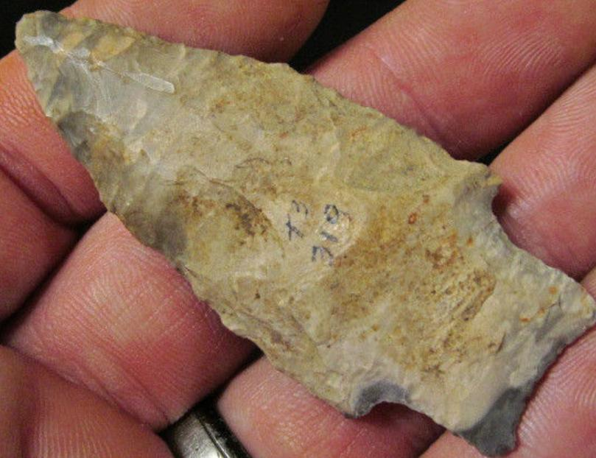 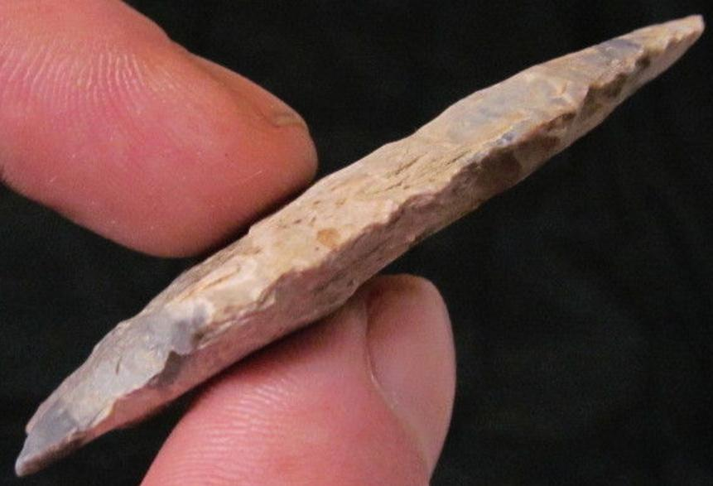

2 7/16" long Heavy Duty point

From: Licking Co., Ohio

Material: an attractive grey and tan multicolored flint material

|  |  |
| --- | --- |
| ORDER DATE  Sep 20, 2015 | ORDER TOTAL  US $30.22  + US $2.95  shipping  **Order 194576278016!534728330018** [View order details](http://payments.ebay.com/ws/eBayISAPI.dll?ViewPaymentStatus&transId=0&itemid=391261734607&_trksid=p2057872.m2749.l2673)[Contact seller](http://contact.ebay.com/ws/eBayISAPI.dll?ShowSellerFAQ&requested=mydirtyolboots&iid=391261734607&redirect=0&_trksid=p2057872.m2749.l2652)  [More actions](http://www.ebay.com/myb/PurchaseHistory) |

2 items sold by[mydirtyolboots](http://www.ebay.com/usr/mydirtyolboots?_trksid=p2057872.m2749.l2754)

|  |  |  |  |
| --- | --- | --- | --- |
| [OUTSTANDING OHIO HEAVY DUTY POINT Arrowhead Authentic Artifact b914](http://www.ebay.com/itm/391261734607?_trksid=p2057872.m2749.l2649&ssPageName=STRK%3AMEBIDX%3AIT)  ( 391261734607 )  Delivered on Fri, Sep 25  Tracking number: [**Tracking number**9400109699938795590178](javascript:;)  [Add note](javascript:;) | ITEM PRICE:  US $7.95 | **Item OUTSTANDING OHIO HEAVY DUTY POINT Arrowhead Authentic Artifact b914 Orders 391261734607-0-0**[Leave feedback](http://feedback.ebay.com/ws/eBayISAPI.dll?LeaveFeedbackShow&useridto=mydirtyolboots&transactID=0&item=391261734607&_trksid=p2057872.m2749.l2665)[Return this item](http://postorder.ebay.com/Return/ReturnViewSelectedItem?transactionId=0&itemId=391261734607&_trksid=p2057872.m2749.l3185)  [More actions](http://www.ebay.com/myb/PurchaseHistory) | |
| [EXCEPTIONAL MISSOURI OOLITHIC ETLEY POINT Arrowhead Authentic Artifact a13](http://www.ebay.com/itm/391261746025?_trksid=p2057872.m2749.l2649&ssPageName=STRK%3AMEBIDX%3AIT)  ( 391261746025 )  Delivered on Fri, Sep 25  Tracking number: [**Tracking number**9400109699938795590178](javascript:;)  [Add note](javascript:;) | | | ITEM PRICE:  US $22.2 |